**Introduction:**

Welcome to the guide. Recently, there has been so many DDOS attacks that I feel compelled to provide these rules for everyone and fight against these nasty people. If you like it, please star my repository <https://github.com/tommytran732/Cloudflare-Firewall-Rules> or check out my website at https://revenact.io

**The basics:**

First of all, you have to make sure the orange cloud is ON. Not having the orange cloud means that your website’s IP is exposed and there is nothing that Cloudflare will do to protect you.



You would also want to change the security level in Firewall -> Settings to High. Cloudflare has this set to Medium by default. The full explanation for the security levels can be founded at

[https://support.cloudflare.com/hc/en-us/articles/200170056-What-does-Cloudflare-s-Security-Le](https://support.cloudflare.com/hc/en-us/articles/200170056-What-does-Cloudflare-s-Security-Level-mean-)

[vel-mean-](https://support.cloudflare.com/hc/en-us/articles/200170056-What-does-Cloudflare-s-Security-Level-mean-), however, we generally want to challenge every IP that can be a potential threat.

DO NOT use the Under Attack Mode (unless you are truly under attack and it is causing you issues). In my experience, the Under Attack Mode is not particularly useful because if the botnet has JavaScript installed it will easily bypass the challenge and hit your website. Not only that, the Under Attack Mode will cause issues with APIs and a whole host of other problems.

Make sure Bot Fight Mode and Browser Integrity Check is on. You do not want botnets faking being legitimate crawlers and access your website.

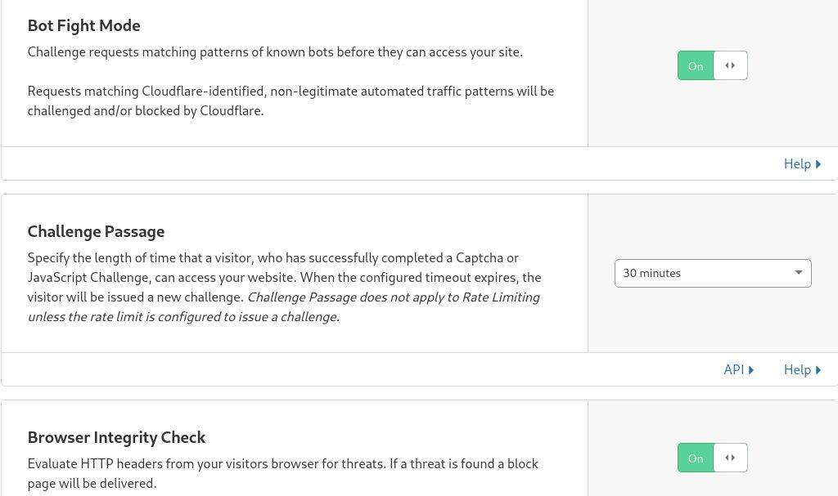

**The firewall**

This is the crucial part that a lot of users ignore/do not configure. These will help block a significant chunk of attacks and will keep your server’s resource usage to a minimum.

Head to Firewall -> Firewall Rules

You can simply add my premade rules by creating a new rule and edit the expression:

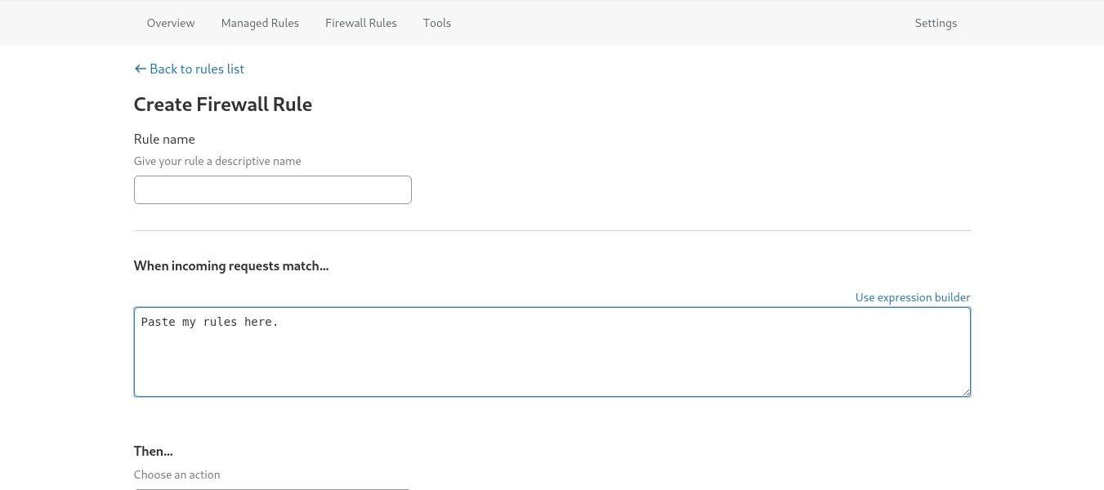

The first rule we are going to add is the rules for known bots. We do not want to block good bots from accessing our website, so we have to make an exception for them.

Add the expression...

(cf.client.bot)

… and set the action to allow.

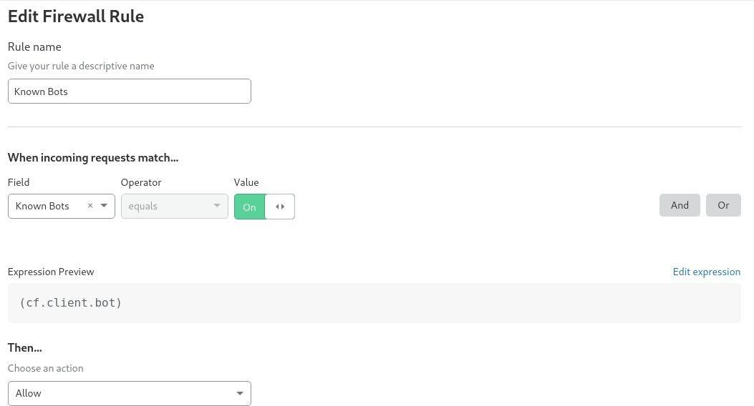

The list of known bots can be founded here:

[https://developers.cloudflare.com/firewall/known-issues-and-faq/#how-does-firewall-rules-handle](https://developers.cloudflare.com/firewall/known-issues-and-faq/#how-does-firewall-rules-handle-traffic-from-known-bots)

[-traffic-from-known-bots](https://developers.cloudflare.com/firewall/known-issues-and-faq/#how-does-firewall-rules-handle-traffic-from-known-bots)

Now, we need to add a rule for emergency situation where every rule including the under attack mode fails. We create this rule right after known bots to give it high priority.

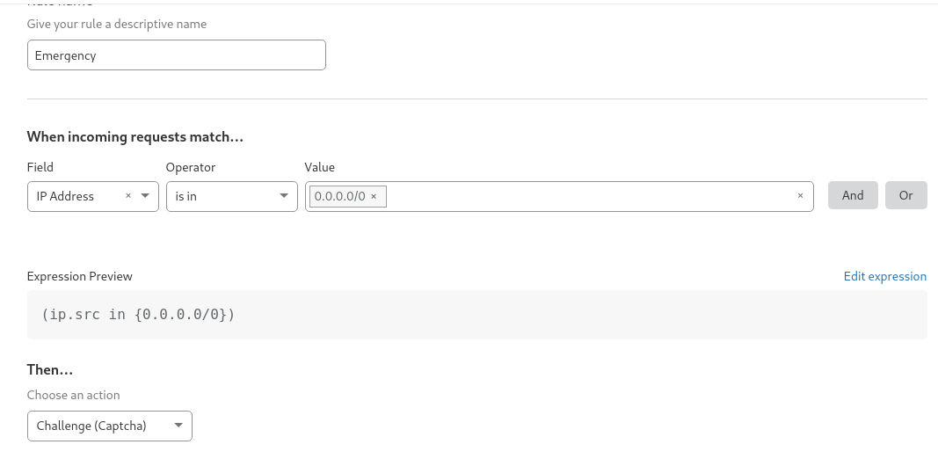

Make sure this rule is disabled unless everything else fails to block the attack. It will force all users except known bots (due to it having lower priority) to solve hcaptcha in order to visit your website.

The next rule we are going to add is the rule for ASNs. We will challenge non residential IPs from accessing your website. Botnets usually contains a large number to servers from OVH, Online.net, etc.. so challenging these ASN will greatly help.

If you don’t feel comfortable with people getting challenged, you can keep these rules off until you get an attack.

(ip.geoip.asnum in {3223 3561 3842 4250 4323 4694 5577 6724 6870

6939 7203 7489 7506 7850 7979 8075 8100 8455 8560 8972 9009 9370

10297 10439 11588 11831 11878 12989 13213 13739 14061 14127

14618 15003 15083 15169 15395 15497 15510 15626 15734 16125

16262 16276 16284 16397 16509 16628 17216 18450 18779 18978

19084 19318 19437 19531 19624 19844 19871 19969 20021 20264

20454 20473 20598 20738 20836 20860 21100 21159 21321 21859

22363 22552 22781 23033 23342 23352 24482 24768 24875 24940

24961 24971 25163 25369 25379 25780 25820 27257 28753 29066

29073 29182 29354 29465 29550 29691 29802 29838 29854 30083

30176 30633 30693 30900 30998 31034 31103 32097 32181 32244

32475 32489 32613 32780 33083 33302 33330 33387 33438 33480

33724 33785 33891 34305 34971 34989 35017 35366 35415 35470

35662 35908 35916 36024 36114 36290 36351 36352 36666 36873

36887 36920 36970 37018 37088 37153 37170 37209 37230 37248

37269 37280 37308 37347 37377 37472 37506 37521 37540 37643

37661 37692 37714 39020 39326 39351 39392 39572 40156 40244

40676 40824 40861 41653 41665 42160 42473 42708 42730 42831

43146 43289 43317 43350 44050 44066 45102 45470 45671 45815

46261 46430 46475 46562 46664 46805 46816 46844 47328 47447

47588 49349 49367 49453 49532 49544 49981 50297 50613 50673

51159 51167 51191 51395 51430 51731 51765 51852 52048 52173

52219 53013 53340 53559 53597 53667 53755 53850 53889 54104

54455 54489 54540 55225 55286 55536 55933 55967 56322 56630

56934 57043 57169 57230 57858 58073 58305 59253 59349 59432

59504 59729 59764 60011 60068 60118 60404 60485 60505 60558

60567 60781 61157 61317 61440 62217 62240 62282 62370 62471

62540 62567 63008 63018 63119 63199 63473 63949 64245 64484

132816 133296 133480 133752 134451 136258 197155 197328 198310

199653 199883 200039 201011 201525 202053 202836 203523 203629

204196 327705 327784 327813 327942 328035 394256 394330 394380

395089 395111 395978 20248 44901 200904 53057 200532 50968

135822 55293 57286 201200 24549 39458 200000 14576 54290 206898

60117 20448 201553 54825 31472 8556 29119 60476 25532 49949

51698 42442 11274 57345 54817 200019 53342 33569 201983 132425

197395 42699 31698 42612 29311 54527 63213 27175 13209 29140

27223 31659 49834 49693 30152 19133 198414 45201 31981 62605

61280 53332 61147 51109 19234 40438 58797 26978 29748 35974

262990 43021 42695 39704 62899 53281 59615 55761 52335 16973

196827 32647 14992 198968 196745 62071 132869 56106 32911 24931

57669 48896 45481 132509 39839 63129 53370 25048 28747 46433

55051 18570 13955 16535 22903 9823 46945 263032 36536 50986

199733 48825 35914 33552 52236 28855 198347 40728 18120 53914

12586 55720 27640 62563 202118 9290 45887 51050 20068 49485

40374 14415 46873 14384 54555 263237 20773 53918 4851 32306

133229 28216 36236 42210 51248 49815 34649 41562 33260 24220

52347 45486 33182 53055 51290 132225 133120 42776 55799 48446

263093 56732 42399 47385 40539 42244 29302 10929 47549 200147

393326 198171 57773 47583 43472 32338 9166 62082 198651 24725

29067 197902 42418 29097 196645 56110 23535 29869 62756 26484

25926 15189 20401 24679 25128 39756 32400 9412 9667 51294 23052

28099 45693 17881 17669 17918 50926 201634 22611 54641 61102

132071 10207 45577 132070 262603 29883 24558 38279 199997 50465

14120 11235 50655 17019 31240 199481 16862 47161 56784 59791

59677 202023 199990 50872 54839 58936 11230 62310 38894 47172

262287 46260 14442 133143 197648 39451 58922 27589 42400 133393

201597 28997 60800 33322 38001 199129 197372 57752 201670 14244

22152 34541 196678 43198 47625 42331 62049 35295 42311 53589

59705 36791 14160 34432 41062 59135 201630 25260 23108 40281

31590 10532 22720 27357 33070 45187 7595 26481 29713 13926 54203

62651 63128 62838 30849 14987 47577 54334 63916 50915 21217

59816 23273 59632 29452 59795 60739 15919 49313 57879 56617

62088 45179 27597 201702 32740 58667 12617 199847 25642 14567

35278 197914 41079 1442 43620 197439 198313 42705 44398 13909

34745 24958 17971 47143 59854 57682 3722 13647 20450 30235 47205

23881 198047 14986 17920 32275 50608 199213 262170 201862 43541

24381 10200 14708 27229 48093 42465 7598 30475})

Set the action to Challenge (NOT JS Challenge - as we have discussed before, the JS Challenge is not very effective. We would want Google ReCaptcha Challenge). Of course, you can be stricter and set it to block instead.

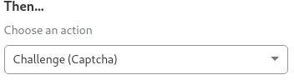

Because of the 4kb/rule limit, we will need to create a second ASN rule for the next set up ASNs:

(ip.geoip.asnum in {55229 7349 33251 52465 52270 45152 8477

198153 52925 61412 262978 53225 41427 53101 41369 35467 59554

52674 24611 48812 40715 201449 52321 29331 201709 53221 198432

51241 19969 56799 26277 58113 28333 42120 6718 20692 17439

132717 9925 132779 42622 6188 40819 24997 38107 36408 57363

46177 62026 61107 58325 19604 23470 39287 12876 60033 13830

60094 37963 31624 26496 48287 132839 204641 35913 39572 32592

23969 9371})

We should also challenge countries that your website does not get a lot of traffic from and is usually responsible for large attacks. Russia, China, and Tor is almost always the case. (Yes, Tor establishes itself as a “Country”. You can use this to challenge access from the Tor Network).

Create a new rule for country challenge:

(ip.geoip.country in {"T1" "CN" "RU" "ID" "BD" "KH" "BR" "SA"

"LY" "ZA" "TH" "IN" "AR"})

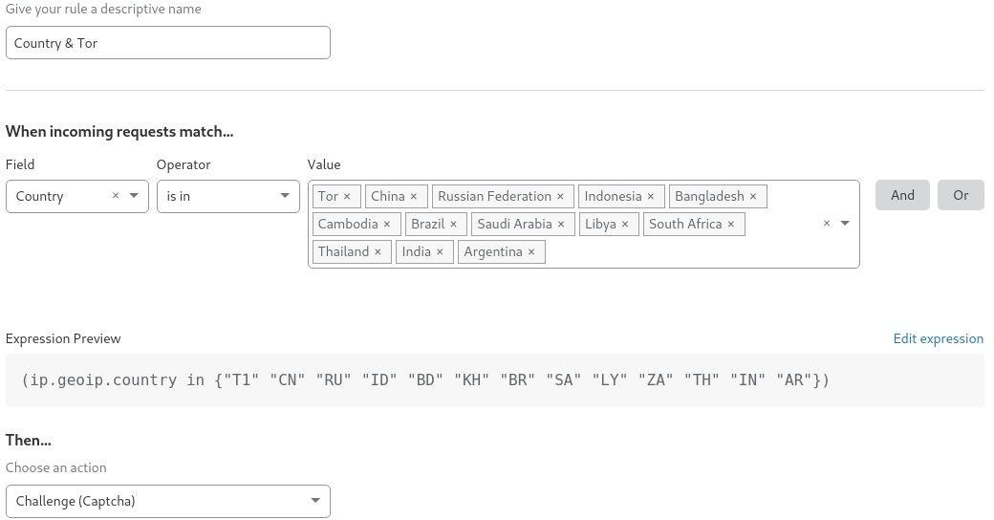

Of course, you should change this rule so that it fits your website.

***Also, please keep in mind the order of the rules. The rules on top will have higher priority***

***than the rules at the bottom. Known Bots should always have the highest priority.***

***If you use something like the Pterodactyl Panel, you will need to head to Firewall -> Tools***

***and whitelist your nodes’ IPs as well.***

**Managed Rules:**

This is a really nice feature that Cloudflare Pro plan above has. I highly recommend that you check it out if you have a paid plan as it can turn out to be very useful.

**Rate Limiting:**

Head to Firewall -> Tools -> Rate Limiting and create a custom rule. Be sure to use * in your expressions.

The limit is highly dependant on your website. Some recommended values are: Plain website: 100 connections/minute -> Block for 1 hour.

Xenforo: 250-350 connections/minute -> Block for 1 hour.

WHMCS: 150 connections/minute -> Block for 1 hour. Pterodactyl: 100 connections/10 seconds -> Block for 1 minute.

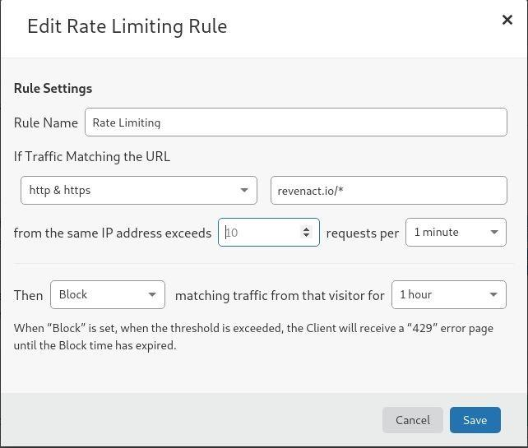

**Other mentions:**

If possible, configure your firewall so that it only accepts connections from Cloudflare. The Layer 7 attacks will become less of a problem even if the attacker finds out the origin IPs because you only accept connections from Cloudflare anyways. The list of Cloudflare’s IPs can be founded here:

<https://www.cloudflare.com/ips/>

If you can afford Cloudflare Argo, I highly recommend that you use it with an Nginx server binded to 127.0.0.1. That way, your website is completely inaccessible unless the traffic goes through cloudflare.

As a alternative, you can use my script here: <https://github.com/tommytran732/Cloudflare-IPWhitelist>

Also, be sure to have no MX records pointing to the same address as your main website. Even with the orange cloud on, the MX record WILL Expose your Origin IP and that will lead to a whole host of other problems. Check the email header of the emails sent by your website as

well, you need to make sure that the Mail Server does not reference the IP of your website there.

**Restore visitor’s IPs:**

As we are proxying behind cloudflare, all connections seen by the web server are from cloudflare. This will undoubtedly create problems with access logging. Make sure you set your web server up to restore the visitor’s IP:

<https://support.cloudflare.com/hc/en-us/articles/200170786-Restoring-original-visitor-IPs-Logging-visitor-IP-addresses-with-mod-cloudflare->

**Bonus rule - Referrer Check:**

Sometimes, some attacks will go through all of the rules above (except the emergency rule), but you don’t want to challenge everyone yet. You can check your web server’s access log and see if all of the connections share anything in common.

For my case, I am using NGINX on RHEL/CentOS 8. I can watch the live logs using

tail -f /var/log/nginx/access.log

As you can see, sometimes, you might see something like this (yes, this is a screenshot from an actual attack on my server):

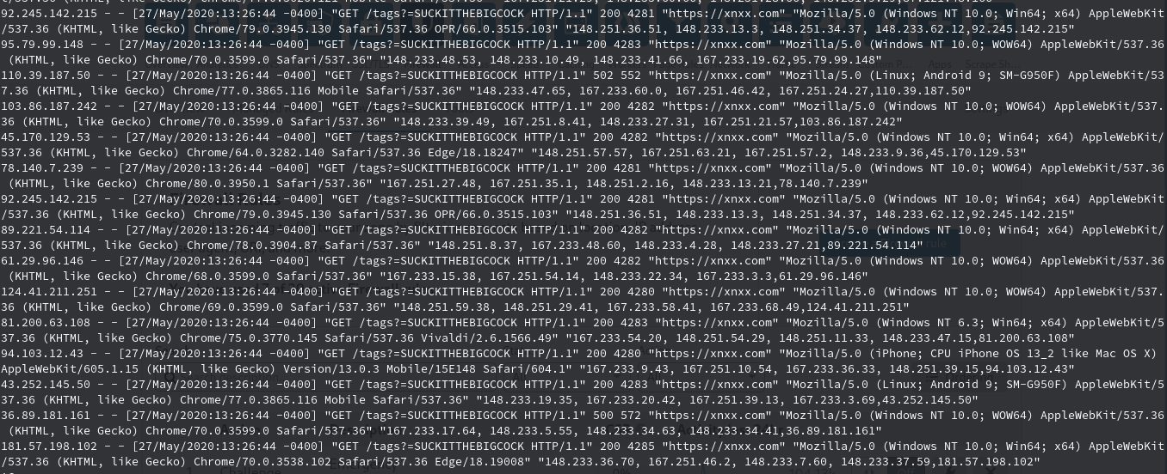

In this case, you can easily see that the attacker is using “<https://xnxx.com>” (Warning: NSFW) as the referrer. All we need to do is to block (or challenge) referrers that have some certain words that the attacker is using:

(http.referer contains "what-risks-are-introduced") or (http.referer contains "suck") or (http.referer contains "boner") or (http.referer contains "gay") or (http.referer contains "porn") or (http.referer contains "xnxx") or (http.referer contains "corona") or (http.referer contains "sex") or (http.referer contains "fuck") or (http.referer contains "chin")